North County Food Policy Council/San Diego Food System Alliance
Introduction to the NCFPC GIS Tool (January 2024)

The North County Food Policy Council, a working committee of The Alliance for Regional Solutions (www.regionalsolutions.net), is indebted to Palomar College for the partnership which makes this tool available. Spring and Fall semester GIS students contribute additions and updates for service-learning credit.

Fall 2023 Palomar College GIS students continued the work of adding and updating mapped information to this GIS tool, to provide a comprehensive platform to assess both food insecurity, and resources, to meet food needs in the San Diego region. Their work consisted of:
- Updating map layers showing concentration of both older age and younger age persons, both indicators of potential food insecurity. Four updated may layers by census tract show these concentrations by both percent of population, and by absolute number of persons.
- Updating a map layer showing public schools which partner with the San Diego Food Bank to provide distribution of food to the food-insecure families of students, via a “backpack” program and an on-campus food pantry program. This map also shows the volume of such food distribution at each school by the size of the icon.

These updated map layers add to the work of previous Palomar GIS students. Also notable, added in Spring 2019, is a polygon layer showing a calculated estimate by zip code area of informal single family dwelling backyard tree fruit production, which gleaning operations should be able to recover; both to reduce solid waste, and for food assistance to the food insecure. This very conservative estimate comes from Karen Clay/My Momma’s Place, https://mymommasplace.com/

Pull up and explore this Web-based GIS tool using the navigation instructions below, to understand the layers and attributes for each layer. Also below is a complete listing of all of the GIS data layers available in this tool.

ACCESSING AND NAVIGATING THE GIS TOOL

From the Alliance for Regional Solutions Web home page (www.regionalsolutions.net), under Committees in the top menu bar, click on North County Food Policy Council. On that page, find the large blue button, “GIS Mapping System.” Click on that button - and the current GIS map will load up. The initial (default) screen will look like this –
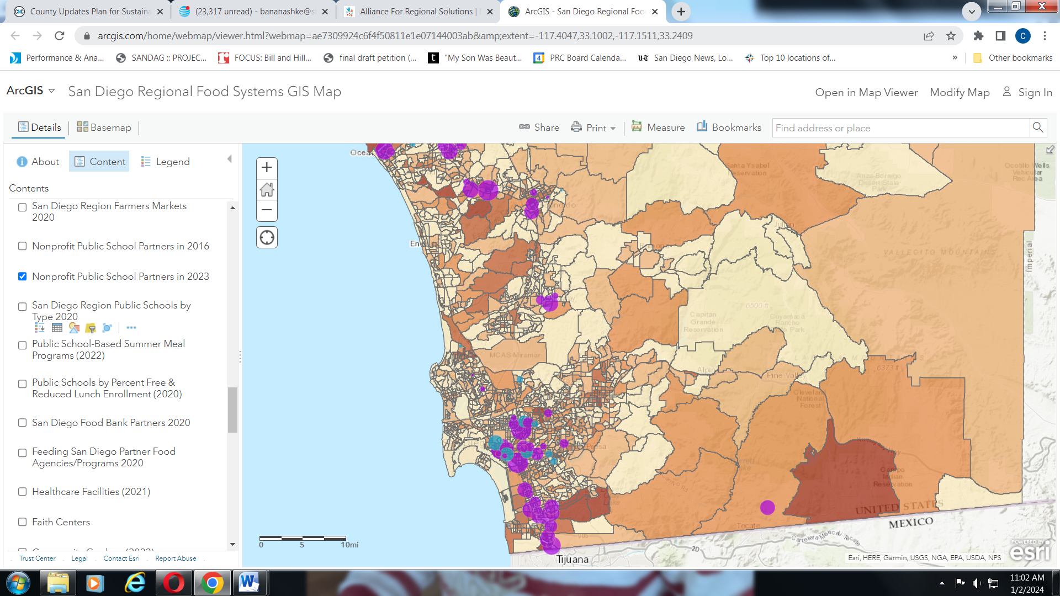

This is the “default” load-up of this tool. Only some of the available data layers are “active” and displayed, there are many other maps not yet active - YOU have the ability of turning off and on different layers, explained below. (The current default layers are persons in poverty, and school-based food assistance programs in our region.) On the left-hand, “legend” side of the screen, is the explanation of symbols of the active layers. (You can scroll up and down to see the legends for all active layers.) On the right-hand side is the map showing active layers.
The legend explains each currently-active GIS layer. The legend describes what each type of layer is, with their different symbols and colors on the map. Again, you can turn on and off all of the different layers, for different comparisons between items. (For example, you may want to see the location and adjacency of nonprofit food assistance agencies/programs, and schools, or faith centers, for partnership opportunities.) Each of the layers displayed on the map are points, or lines, or areas (polygons) on the map.
In the very left upper-hand corner, note that “details” is underlined. To the right of “details” is “basemap.” You can click on this button to bring up choices of different underlying basemaps, depending on your desires/needs. Play with this to see what may work best for you at any time!
- Not yet active are additional layers. Many are polygons (areas). In addition to city boundaries (very useful to see resources in specific jurisdictions), other polygon layers are displays of backyard gleaning potential, community areas by concentrations of several population characteristics, indicators of potential food insecurity including poverty, Hispanic population, older age, younger age, households receiving SNAP (food stamps), single parent/guardian households. There is also a polygon layer of federally-defined food insecurity. (The Food Policy Council’s initial work confirmed that these population demographics are associated with food insecurity.) Again, YOU have the capability of turning on and off these demographic indicators (instructions below).

On the right-hand side of the screen is the map of active layers. Three things:
- If you mouse-click right on top of any one of the point, line or polygon symbols, information details (“attributes”) of that one item will pop up on the screen. Play with this to see what information is available here on each type of item in each layer.
- If you go to an area of the map without any symbol, mouse-click and hold, you can move the map around to different community areas.
- In the upper-left hand corner of the map, are buttons allowing you to zoom in, and zoom out. You can zoom out to see the whole state or country; and you can zoom way, way in to any particular location.

- Here’s how to turn on and off the different map layers:

Back on the left-hand side of the screen toward the top, note that “Legend” is highlighted and active.
- Mouse click on “Content” button right next to Legend. Note that the left-hand side now changes, and you can click to check on, or check off, any one of the layers included in this GIS map. Those layers active by default are already checked; others are not checked, and you can activate them.
- Among the layers are ten demographic items, concentrations of:
- Hispanic population;
- Black population;
- people below 18 years;
- people 65 years and older;
- two different displays of poverty, by absolute numbers in any polygon, and by percentage of total population in a polygon;
- food insecurity;
- Households receiving SNAP (food stamp) assistance
- Unemployment
- Single parent/guardian households
- Normally, you will want to have only one of these polygon layers active at any time, as the overlapping colors will be confusing. For any of these demographics, the darker the color of the polygon, the higher the concentration; so that darker colors are concentrations of persons potentially food-insecure. The legend display will tell you the concentration for any color. For most of these layers, the polygons are census block groups; polygons for the USDA food insecurity layer are census tracts.

There are also other polygon layers showing census tract boundaries, and cities’ boundaries; and the polygon layer showing backyard gleaning potential by zip codes. Besides all these polygon displays are point and line data layers – all described below. Again, turn on and off to see single items, or compare multiple items with each other.

This is a good beginning for exploring the North County Food Policy Council GIS map, care of Palomar College. Below is a complete listing of all of the data layers available in this tool. There is much more information/functionality in this Web tool, which you are free to explore!

EXISTING NCFPC GIS DATA LAYERS (as of January 2024)
except where noted, all of these cover the full San Diego County region

Polygon layers (mapped information in area shapes, as opposed to points or lines):
- Estimate of potential for gleaning backyard tree produce, by zip code
- Concentration of food insecurity (US Census/USDA defined), % of population, in census tracts, 2016
- Concentration of poverty, % of population, in census block groups, 2019
- Concentration of poverty, absolute numbers of persons, in census block groups, 2019
- Concentration of older age, 65+, absolute numbers, in census tracts, 2021
- Concentration of older age, 65+, by percent of total population, in census tracts, 2021
- Concentration of young age, 18 and under, absolute numbers, in census tracts, 2021
- Concentration of young age, 18 and under, by percent of total population, in census tracts, 2021
- Concentration of ethnicity Hispanic, absolute numbers, in census block groups, 2019
- Concentration of racial group Black, absolute numbers, in census block groups, 2019
- Concentration of households receiving SNAP food assistance, absolute numbers, in census block groups, 2019
- Concentration of numbers of persons unemployed, census block groups, 2019
- Numbers of single parent or guardian households, differentiated by single women and single men, in census block groups, 2019
- Municipal boundaries, all cities in region and County unincorporated
- U.S. Census tracts, boundary outlines, 2016

Line layers:
- Public transit routes, full County region: routes by type (also see point layers: stations/stops, and ¼ mile access), 2023
Point layers:
Per California State law SB1383, cities and counties must identify generators of food waste, as well as agencies that can take in food that is donated so as not to go to landfill. Pursuant to this, our GIS platform has mapped some cities’ and the County’s waste stream/wasted food data in two generations: “First generation” information, showing sites generating food waste, by type of land use, and by calculated annual volume of wasted food. “Second generation” information showing sites which come under a State-defined hierarchy of food waste generators, Tier 1 and Tier 2.
SB 1383 “first generation” map layers:
- County of San Diego unincorporated, SB1383 commercial edible food generators, by business type
- City of Imperial Beach, SB 1383 generators of potentially recoverable food, by type of generator, 2020
- City of Imperial Beach, SB 1383 generators of potentially recoverable food, by volume of food waste, 2020
- City of Poway, SB 1383 generators of potentially recoverable food, by type of generator, 2019
- City of Poway, SB 1383 generators of potentially recoverable food, by volume of food waste, 2019
- City of Encinitas, SB 1383 generators of potentially recoverable food, by type of generator, 2019
- City of Encinitas, SB 1383 generators of potentially recoverable food, by volume of food waste, 2019
- City of Solana Beach, SB 1383 generators of potentially recoverable food, by type of generator, 2019
- City of Solana Beach, SB 1383 generators of potentially recoverable food, by volume of food waste, 2019
- City of Chula Vista, SB 1383 generators of potentially recoverable food, by type of generator, 2019
- City of Chula Vista, SB 1383 generators of potentially recoverable food, by volume of food waste, 2019
- City of Del Mar, SB 1383 generators of potentially recoverable food, by type of generator, 2018
- City of Del Mar, SB 1383 generators of potentially recoverable food, by volume of food waste, 2018
- City of La Mesa, SB 1383 generators of potentially recoverable food, by volume of food waste, 2018
- City of La Mesa, SB 1383 generators of potentially recoverable food, by type of generator, 2018
- City of Oceanside, SB 1383 generators of potentially recoverable food, by type of generator, 2018
- City of Oceanside, SB 1383 generators of potentially recoverable food, by volume of food waste, 2018
- City of Vista, SB 1383 generators of potentially recoverable food, by type of generator, 2018
- City of Vista, SB 1383 generators of potentially recoverable food, by volume of food waste, 2018
- City of San Marcos, SB 1383 generators of potentially recoverable food, by type of generator, 2018
- City of San Marcos, SB 1383 generators of potentially recoverable food, by volume of food waste, 2018
- City of Escondido, SB 1383 generators of potentially recoverable food, by type of generator, 2019
- City of Escondido, SB 1383 generators of potentially recoverable food, by volume of food waste, 2019
SB 1383 “second generation” Tier 1 and Tier 2 map layers:
- County of San Diego unincorporated, SB1383 commercial edible food generators, Tier 1
- County of San Diego unincorporated, SB1383 commercial edible food generators, Tier 2
- City of Coronado, SB1383 commercial edible food generators, Tier 1
- City of Coronado, SB1383 commercial edible food generators, Tier 2
- City of Chula Vista, SB1383 commercial edible food generators, Tier 1
- City of Chula Vista, SB1383 commercial edible food generators, Tier 2
- City of Encinitas, SB1383 commercial edible food generators, Tier 1
- City of Encinitas, SB1383 commercial edible food generators, Tier 2
- City of Solana Beach, SB1383 commercial edible food generators, Tier 1
- City of Solana Beach, SB1383 commercial edible food generators, Tier 2
Other Point Layers:
- Food outlets by type, comprehensive; 5 categories, as licensed by County Health 2021
- Food agencies/programs which partner with San Diego Food Bank; red circles, the larger the circle the greater the total volume of food that agency/program received for public distribution from the Food Bank in 2020
- Food agencies/programs which partner with Feeding San Diego; light purple circles, the larger the circle the greater the total volume of food that agency/program received for public distribution from Feeding SD in 2020
- Public school based Summer meal programs, 2022
- Public Schools with San Diego Food Bank Backpack Programs (2023)
- Public Schools with San Diego Food Bank School Pantries (2023)
- Public schools County wide, by type (elementary, middle, high school, charter, alternative, continuation, special education, County community, K-12), 2020
- Healthcare Facilities, full County region, 2021
- Public transit, full County region: stops/stations, 2023
- Public transit, full County region: ¼ mile access radius around each station/stop, 2023
- Farmers markets, full County region, 2020
- Community gardens, full County region, 2022
- Public schools for full County region, by % student enrollment qualifying for subsidized meal, 2020
- Faith centers

